**Viewing claims paid by HRA (after meeting your deductible)**

Go to Claims under the Claims & Payments tab on your account.

Choose a claim (preferably one that has an amount under “Your Responsibility”).

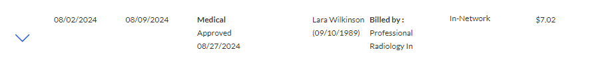



Click on the drop-down arrow to open the claim details.

Scroll to the bottom of the claim details click on “Go to your spending account”.

This will open a new screen with the information about the HRA payment.

